# Assignment # 2: Repetitive Structures

## Objectives:

To be familiar with formatted and unformatted I/O in C++

To understand the programming using repetitive structures

## Tasks:

1. Calculate the sum of odd natural numbers 1+3+5+7+……………. .+n using while loop. Take n as input from user.
2. Write a program to find sum as Y of the following series excluding multiples of 3 in the series:

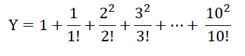

1. Write a program to produce the output as shown below using spaces and tabs:

x | y | expressions | results

6 | 3 | x=y+3 | x=6

6 | 3 | x=y-2 | x=1

6 | 3 | x=y*5 | x=15

6 | 3 | x=x/y | x=2

6 | 3 | x=x%y | x=0

1. Given x=3.0, y=12.5, z= 523.3, A=300.0, B=1200.5, C=5300.3, Write a program to display the following using spaces and tabs in cout statement:

x y z= 3.0 | 12.5 | 523.3 |

A B C= 300.0| 1200.5| 5300.3|

-----------------------------------------------------------------------------------------

X y z= |3.00 |12.50 |523.30

A B C= |300.00 |1200.50 |52300.30

1. Write a program that reads n integers as input from user and display the maximum value that the user entered (using do while loop).
2. Write a program to calculate GPA for multiple of students. Your program shall asks each student to enter the number of subjects, credit hours of each subject and grade of each subject. Display the GPA obtained by the student. Your program shall ask the user if there are other students who want to calculate their GPA. Calculate again if the user enters y/Y (using do while loop).
3. Use nested for loops (Loops inside Loops) to construct programs that display the following patterns.

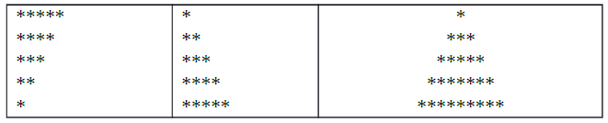

1. Write a program to display the following (using while loop):
2. 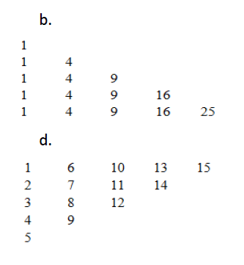
3. 
4. Write a program to find the sum & reverse of digits and check if it is Palindrome or not. Your program shall output the reverse of the same with suitable messages.

Ex: Num: 2014, Reverse: 4102, Not a Palindrome

Ex: Num: 12521, Reverse: 12521, Palindrome

1. Write a program to check whether a given 3 digit number is Armstrong number or not.

An Armstrong number of three digits is an integer such that the sum of the cubes of its digits is equal to the number itself. For example, 371 is an Armstrong number since 33 + 73 + 13 = 371.

For Example: 1643 is an Armstrong number since 14 + 64 + 44 + 34 = 1643.

1. Write a program to count number of digits and bits in a number.